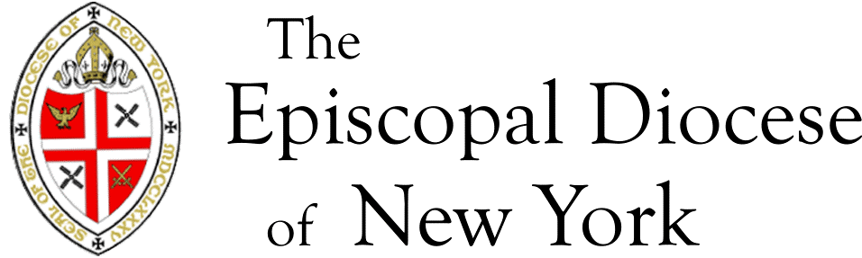

Tax-Excludable Clergy Parsonage Allowance Certification

To: Zoraida Marte, Payroll Manager

From: ______________________________________

Congregation: ______________________________________

Clergy Person: ________________________________________

This is to advise you that for the year __________ the Vestry/Advisory Board of the above congregation has adopted the required resolution designating a portion of the above clergyperson’s compensation as a tax-excludable parsonage allowance. In any event until further notice, the designated amount above shall be used as a Tax Excludable Parsonage Allowance

Of a total cash compensation of $_______________ for the year (see line (G)
of Compensation Worksheet), $_______________ has been designated as a tax-excludable parsonage allowance.

Please note:

The amount designated by the Vestry in its resolution should not exceed the amount expected to be spent on housing-related expenses. The tax excludable clergy parsonage allowance can be raised or lowered for future pay periods, but no retroactive adjustments are permitted under IRS regulations. The most that can be excluded from income tax is the least of the following figures:

- The appropriate fair market rental value
- The amount of this designation; or
- The actual amount spent on housing-related expenses

It is up to the clergyperson to keep records proving that she/he has spent at least the designated amount for expenses related to providing a home. Unspent amounts must be included on Form 1040 as taxable income. The entire parsonage allowance is subject to self-employment tax and must be included on Schedule SE.

Authorized Signature:

__________________________________ _____________________________________
Print Signature\Title

Date: ____________________________

ZORAIDA MARTE - PAYROLL MANAGER
1047 AMSTERDAM AVENUE NEW YORK NY 10025 T: 212.316.7478 F:212.932-7328 ZMARTE@DIOCESENY.ORG

